The feeding is made via an intermediate hopper of 40litres fixed by pivot to the frame.
This hopper feeds the conveyor via a variable frequency vibrating conveyor.
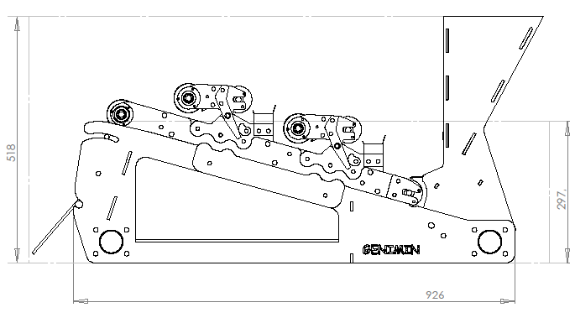
3 magnetic drums
Conveyor width : 600mm
Capacity : 1 to 6 t/hour
Conveyor speed : de 0 to 15m/min
Transport dimension : 950 * 600 * 700

Weight : 120kg

The 3 conveyors are powered by drums brushless motors with internal planetary gear head. The protection is IP65. The speed of those BLDC motors are regulated by an electronic driver.
The total power is only 150W on 24V. Thanks to a robust construction and to low fuel consumption, this separator is as well adapted has an industrial use as an artisanal use.



