The power of a magnet to attract a paramagnetic mineral is not only a function of magnetic field strength but also and primarily a function of magnetic field gradient. This gradient is the rate of growth of the magnetic field. The direction corresponding to the maximum gradient is also the direction of force applied to the mineral.
This force F is then expressed: F = μ H dH / dt
Where H is the intensity of magnetic field and dH / dt is its gradient. How to create an intense magnetic field and a large gradient is an important aspect of the design of the separator.
The intensity of the magnetic field gradient must be considered depending on the size and location of the particle. The average location of the particles towards the magnetic poles is a very important parameter to consider in the design of the separator to maximize the intensity of magnetic field gradient within the particle.

THE SPECIAL ARRANGMENT OF STRONG PERMANENT MAGNETS (NODYMIUM N52)
MAKES A MAXIMUM MAGNETIC FIELD and AN OPTIMAL GRADIENT INSIDE THE PARTICLES

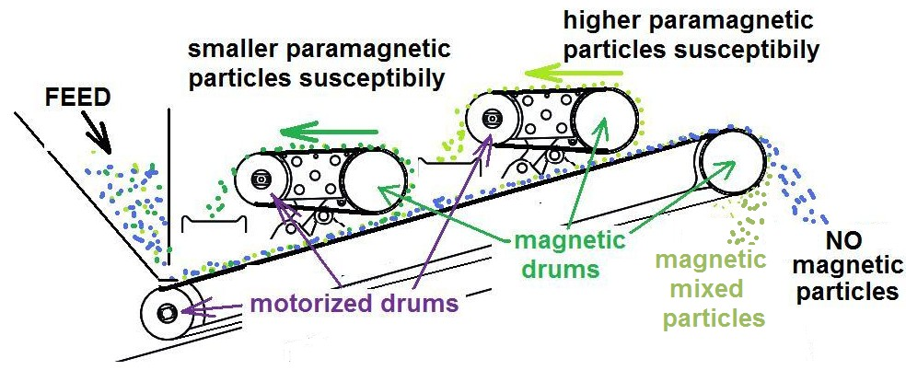

3 magnetic drums make 3 different separations according of the parameters of those magnetic drums.
The two first magnetic drums of separation are situated over the particles that have to jump on them. A very thin belt is powered by a drum motor and is drived on the magnetic belt. This belt is running in the same direction and same speed than the particles that have to jump on. The gap between the particles and the magnetic drum is kept as minimum as possible. For this reason, the module with this magnetic drum can pivot to allow an oversize particle to continue its way. The particles attracted by the magnetic drum are transported by transported by the conveyor to a transversal and vibrating one.

The first drum can be delivered to select only the ferromagnetic particles.

The conveyor belts are an important element in the design of the separator as being between particles and magnets. Indeed, the adhesive strength of particles is a function of the inverse square of the distance should therefore be minimized.  The bands are made of polyurethane composite for high abrasion resistance, high tensile strength and a minimum thickness (0.1 mm). | 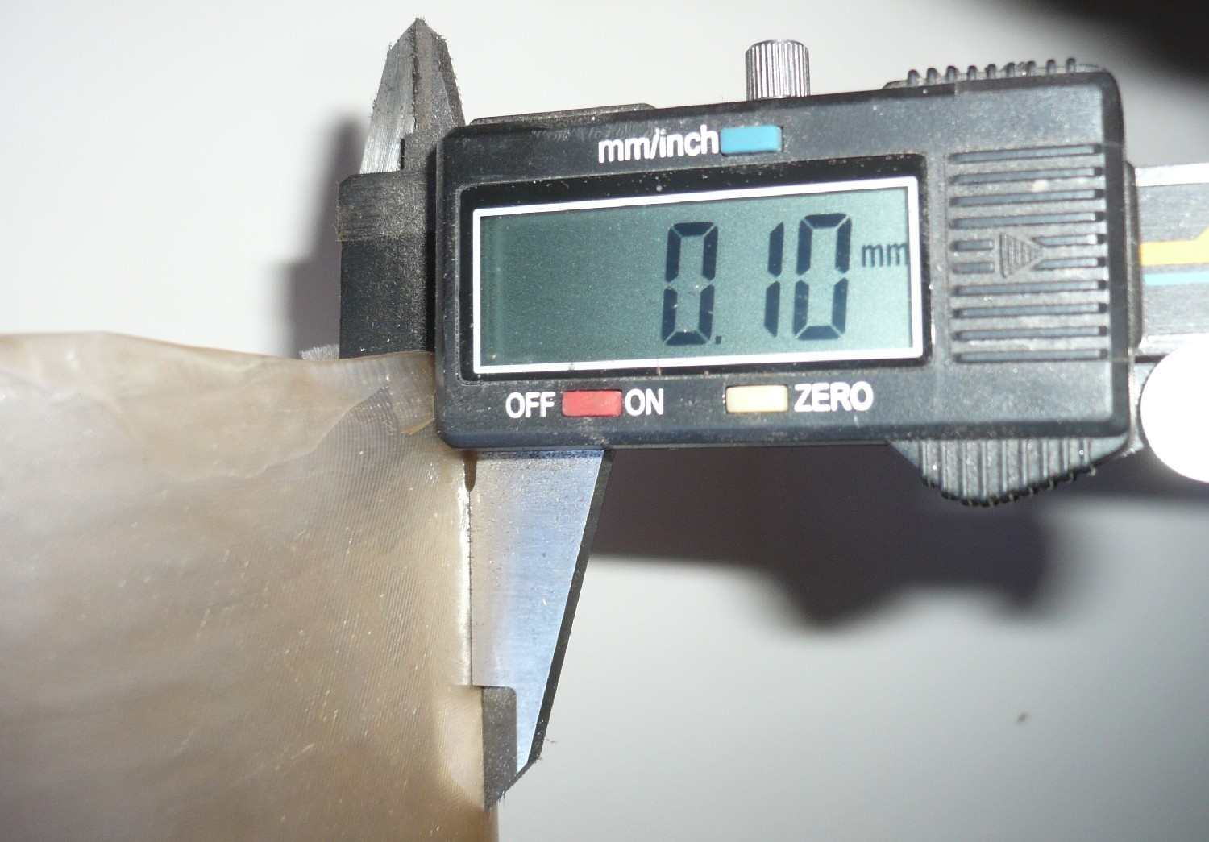

The modular construction provides an ease and quick change of belts.
Being lightweight and robust, the separator is adapted to work in small scale mining too.
The motor and planetary gear are integrated with drums have maximum protection IP65.
Consumption is very small; the installed power is only 150W at 12VDC

